


AI/ML INTERNSHIP

AN INTERNSHIP REPORT

Submitted by

VIBHA BINOY SASIDHARAN -20221IST0020

Under the guidance of,
Mr. JINESH VN

BACHELOR OF TECHNOLOGY

IN

INFORMATION SCIENCE AND TECHNOLOGY


(ARTIFICIAL INTELLIGENCE AND DATA SCIENCE)

PRESIDENCY UNIVERSITY
BENGALURU
APRIL 2026



PRESIDENCY SCHOOL OF COMPUTER SCIENCE AND ENGINEERING
BONAFIDE CERTIFICATE

Certified that this report “AI/ML Internship” is a bonafide work of Vibha Binoy Sasidharan(20221IST0020) who has successfully carried out the internship work and submitted the report for partial fulfilment of the requirements for the award of the degree of BACHELOR OF TECHNOLOGY in INFORMATION SCIENCE AND TECHNOLOGY (ARTIFICIAL INTELLIGENCE AND DATA SCIENCE) during 2025-2026.

Mr. Jinesh VN  Project Guide  PSCS  Presidency University | Mr. Saptarsi Sanyal  Program Internship Coordinator  PSCS  Presidency University | Dr. Md Ziaur Rahaman  School Internship Coordinator  PSCS  Presidency University

Dr. Pallavi R  Head of the Department,  PSCS  Presidency University | Dr. Duraipandian N  Dean  PSCS / PSIS  Presidency University

Name and Signature of the Examiners
Sl. No | Name | Signature | Date
1 | Mr. Jinesh VN
2 | Mr. Sunil Sahoo

PRESIDENCY UNIVERSITY

PRESIDENCY SCHOOL OF COMPUTER SCIENCE AND ENGINEERING
DECLARATION

I am a student of final year B.Tech in INFORMATION SCIENCE AND TECHNOLOGY(ARTIFICIAL INTELLIGENCE AND DATA SCIENCE), at Presidency University, Bengaluru, named Vibha Binoy Sasidharan, hereby declare that the internship work titled “AI/ML Internship” has been independently carried out by me and submitted in partial fulfillment for the award of the degree of B.Tech in INFORMATION SCIENCE AND TECHNOLOGY(ARTIFICIAL INTELLIGENCE AND DATA SCIENCE) during the academic year of 2025-2026. Further, the matter embodied in the internship has not been submitted previously by anybody for the award of any Degree or Diploma to any other institution.

Vibha Binoy Sasidharan | 20221IST0020

PLACE: BENGALURU
DATE: 25 - April 2026

INTERNSHIP COMPLETION CERTIFICATE

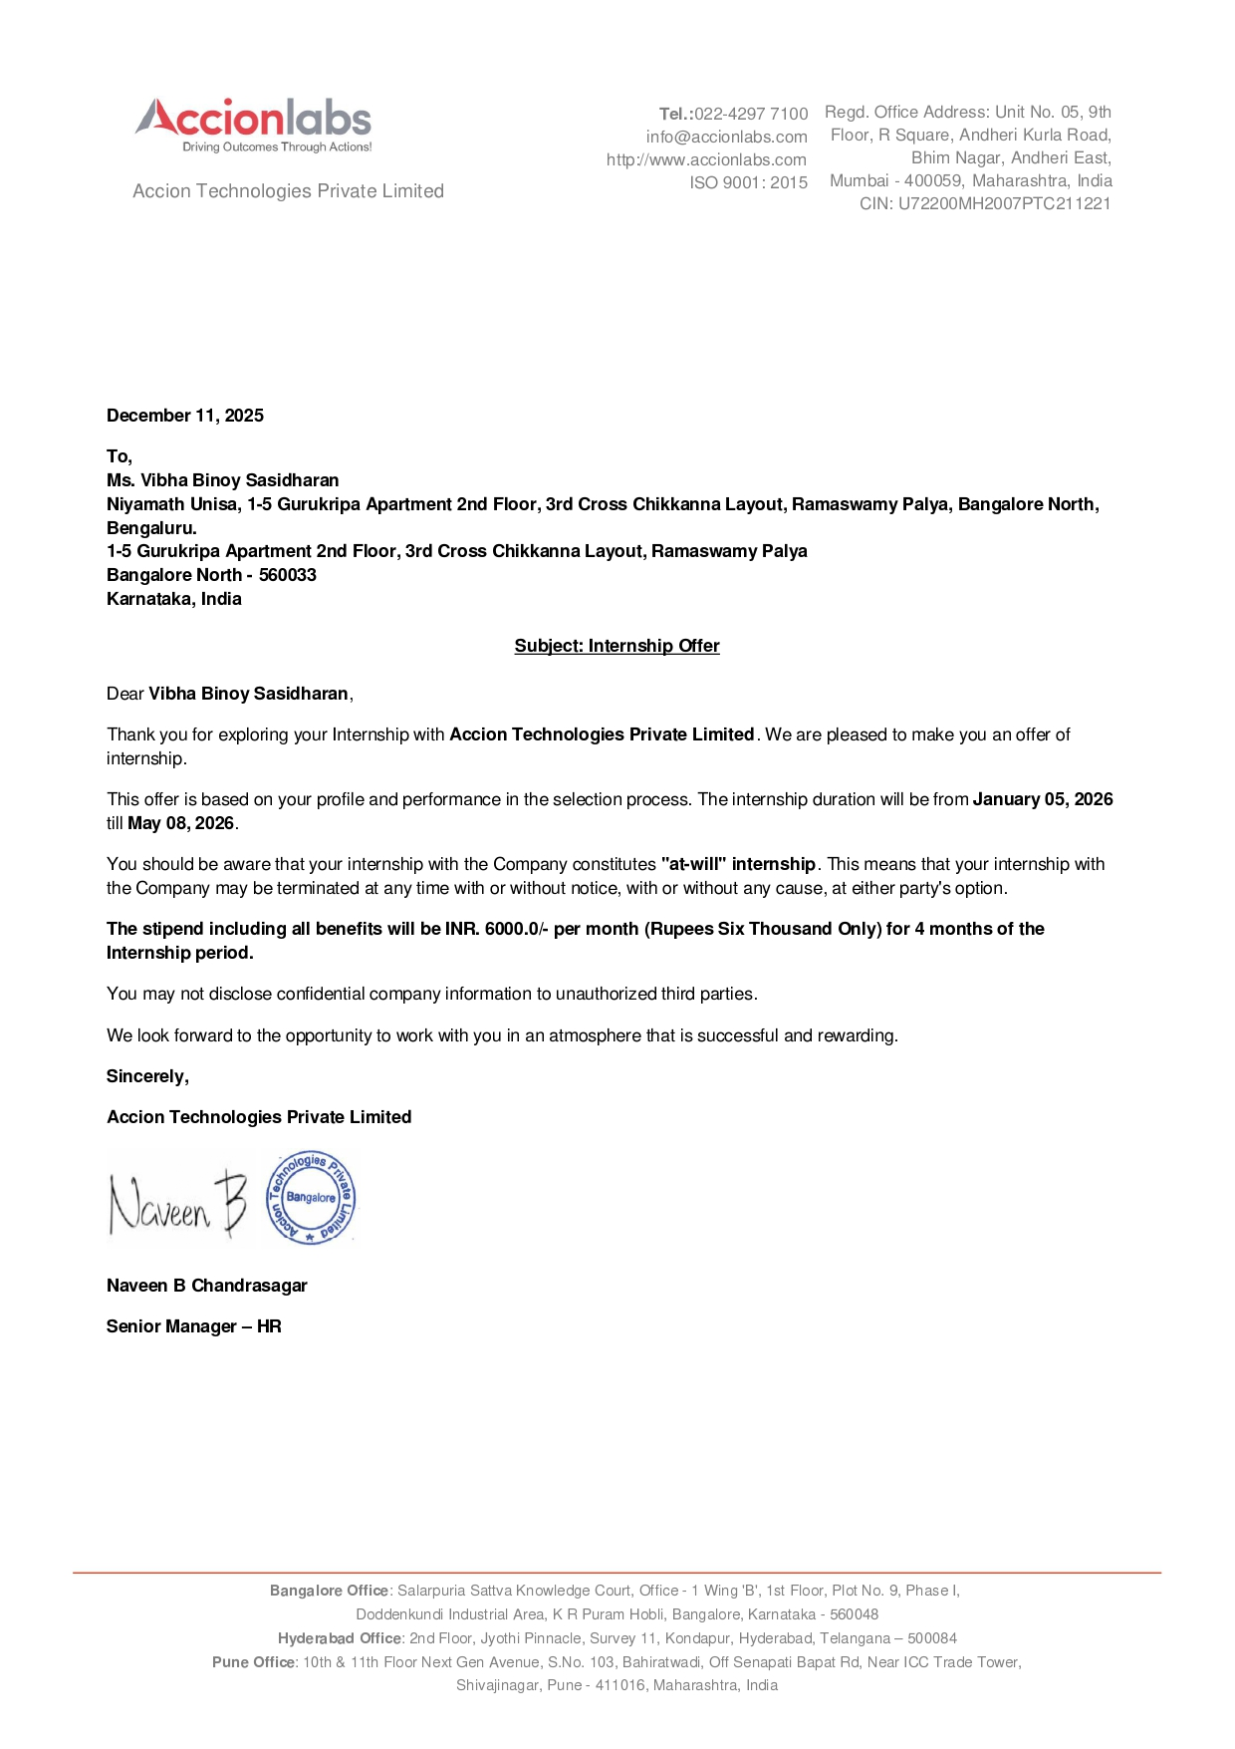
ACKNOWLEDGEMENT

For completing this internship work, I have received the support and the guidance from many people whom I would like to mention with deep sense of gratitude and indebtedness. I extend my gratitude to our beloved Chancellor, Pro-Vice Chancellor, and Registrar for their support and encouragement in completion of the internship.
I would like to sincerely thank my internal guide Mr. Jinesh VN, Assistant Professor, Presidency School of Computer Science and Engineering, Presidency University, for his moral support, motivation, timely guidance and encouragement provided to me during the period of internship work.
I am also thankful to Dr. Pallavi R, Professor, Head of the Department, Presidency School of Computer Science and Engineering, Presidency University, for her mentorship and encouragement.
I express my cordial thanks to Dr. Duraipandian N, Dean PSCS & PSIS and the Management of Presidency University for providing the required facilities and intellectually stimulating environment that aided in the completion of my internship work.
I am grateful to Dr. Md Ziaur Rahaman, Internship Coordinator and Mr. Saptasi Sanyal
, Program Internship Coordinator, Presidency School of Computer Science and Engineering, or facilitating problem statements, coordinating reviews, monitoring progress, and providing their valuable support and guidance.
I am also grateful to Teaching and Non-Teaching staff of Presidency School of Computer Science and Engineering and also staff from other departments who have extended their valuable help and cooperation.

Vibha Binoy Sasidharan

ABSTRACT

This internship was undertaken to gain practical exposure to modern software development practices and to bridge the gap between academic learning and industry requirements. The work primarily focused on developing full-stack applications, understanding data processing workflows, and implementing real-world solutions using contemporary technologies. The internship provided hands-on experience in Python programming, web development, database management, and frontend design implementation.

The internship began with building a strong foundation in Python programming, covering essential concepts such as data types, control structures, and functions. This was followed by working on a data quality testing platform, where multiple databases including MySQL, MongoDB, and Elasticsearch were explored to understand data validation processes. Further, a data pipeline application was developed to process Parquet files and load them into SQL Server using Flask APIs, incorporating ETL concepts and API testing with Postman. A web scraping application was also created to extract and display data dynamically using Flask and Jinja templates, enabling integration between backend logic and frontend interfaces.

In addition, a modern web application for property and booking management was developed by converting a pre-designed Figma layout into a production-ready frontend using React, TypeScript, and Tailwind CSS. During this process, AI-assisted development tools such as Antigravity, Claude, and similar platforms were utilized to generate code, refine components, and accelerate development through prompt-based interactions. The application included features such as OTP-based authentication, backend API integration readiness, responsive design, and payment integration using Razorpay. This task highlighted the practical use of AI tools in enhancing development efficiency and implementing complex frontend systems.

Overall, the internship resulted in the successful development of multiple functional applications and significantly enhanced technical skills in full-stack development, API design, database interaction, and modern frontend frameworks. It also improved problem-solving abilities and provided valuable exposure to emerging AI-assisted development practices alongside traditional software engineering approaches.

TABLE OF CONTENTS
CHAPTERS | TITLE | PAGE NO.
 | Declaration | 3
 | Acknowledgement | 5
 | Abstract | 6
 | List of Figures | 9
 | List of Tables | 10
 | Abbreviations | 11
1. | INTRODUCTION | 12
 | 1.1 Background | 12
 | 1.2 Statistics of Internship | 12
 | 1.3 Prior existing technologies | 12
 | 1.4 Proposed approach | 12
 | 1.5 Objectives | 13
 | 1.6 SDGs | 13
 | 1.7 Overview of internship report | 14
2. | LITERATURE REVIEW | 15
3. | METHODOLOGY | 17
4. | PROJECT MANAGEMENT | 19
 | 4.1 Internship Timeline | 19
 | 4.2 Risk analysis | 19
 | 4.3 Internship budget | 20
5. | ANALYSIS AND DESIGN | 21
 | 5.1 Requirements | 21
 | 5.2 Choosing devices | 21
 | 5.3 Database and Data Management | 21
 | 5.4 Security and Privacy | 21
 | 5.5 System Flow Chart | 22
 | 5.6 Design Considerations | 23
 | 5.7 Prototype Validation | 23
 | 5.8 Future Design Enhancements | 23
6 | HARDWARE,SOFTWARE AND SIMULATION | 24
 | 6.1 Hardware | 24
 | 6.2 Software Development Tools | 24
 | 6.3 Software code | 25
 | 6.4 Simulation | 26
7. | EVALUATION AND RESULTS | 27
 | 7.1 Test Points | 27
 | 7.2 Test Plan | 27
 | 7.3 Test Result | 27
 | 7.4 Insights | 30
8. | SOCIAL, LEGAL, ETHICAL, SUSTAINABILITY AND SAFETY ASPECTS | 31
 | 8.1 Social Aspects | 31
 | 8.2 Legal Aspects | 31
 | 8.3 Ethical Aspects | 31
 | 8.4 Sustainability Aspects | 32
 | 8.5 Safety Aspects | 32
9. | CONCLUSION | 33
10 | REFERENCES | 34
11 | APPENDIX | 35

LIST OF FIGURES

FIGURE | CAPTION | PAGE NO
Figure 1.1 | SDGs | 12
Figure 4.1 | Internship Timeline | 18
Figure 5.1 | Workflow for StaynGo Hotel Booking | 21
Figure 6.1 | Code: Using BeautifulSoup for Web Scraping | 24
Figure 6.2 | Code: Creating API Endpoint | 25
Figure 6.3 | API testing using Postman | 25
Figure 7.1 | Parquet Loader UI | 27
Figure 7.2 | Data Pipeline Output | 27
Figure 7.3 | UI of Testing Platform(1) | 28
Figure 7.4 | Test Results | 28
Figure 7.5 | Web Scraper UI | 28
Figure 7.6 | StaynGo Web Design for User(1) | 29
Figure 7.7 | StaynGo Web Design for User(2) | 29
Figure A 1 | Data Uploaded in SQL Server for Parquet Loader | 34
Figure A 2 | Figure A-2: UI for DataInt Testing Platform | 34
Figure A 3 | Figure A-3: UI for StaynGo Hotel Booking Platform | 35

LIST OF TABLES

TABLE | CAPTION | PAGE NO
Table 6.1 | Software Development Tools | 24

ABBREVIATIONS

Abbreviation | Full Form
SQL | Structured Query Language
HTML | Hypertext Markup Language
CSS | Cascading Style Sheets
API | Application Programming Interface
ETL | Extract Transform Load
UI/UX | User Interface/User Experience
OTP | One Time Password

Chapter 1
INTRODUCTION
1.1 Background
The internship was undertaken to gain practical exposure to modern software development practices and to understand how real-world applications are built and deployed. With the increasing adoption of full-stack development and intelligent systems, the internship focused on combining traditional programming skills with emerging technologies such as AI-assisted development. The work involved developing applications that integrate backend systems, databases, and responsive user interfaces, reflecting current industry trends.

1.2 Statistics of Internship
The internship was conducted over a period of approximately four months, during which five major tasks were completed across different domains of software development. The work involved technologies such as Python, Flask, SQL Server, MongoDB, Elasticsearch, HTML, Jinja Templates, React, TypeScript, and Tailwind CSS. In addition, AI-based development tools were utilized to assist in coding, debugging, and optimizing frontend components. The internship included both learning-oriented and implementation-based activities, along with continuous testing using tools like Postman.

1.3 Prior Existing Technologies
Before the adoption of modern development practices, many applications relied on manual coding approaches with limited automation and scalability. Traditional systems often lacked efficient data processing pipelines and seamless integration between frontend and backend components. Additionally, earlier development workflows did not incorporate AI assistance, requiring developers to rely solely on documentation and manual debugging. These limitations often resulted in slower development cycles and reduced efficiency in handling complex systems.

1.4 Proposed Approach
The approach followed during the internship focused on integrating modern full-stack development practices with AI-assisted tools. Python was used for backend development and data processing, while Flask was employed to create RESTful APIs. Data pipelines were implemented using ETL concepts to handle structured and unstructured data efficiently. For frontend development, a Figma-based design was converted into a responsive application using React, TypeScript, and Tailwind CSS. AI tools such as Antigravity and Claude were utilized to generate code, improve design implementation, and accelerate development through prompt-based interactions. The approach emphasized modularity, scalability, and efficient development practices.

1.5 Objectives
The primary objective of the internship was to gain hands-on experience in full-stack development and understand real-world application design. Specific objectives included learning Python programming, developing RESTful APIs using Flask, implementing data pipelines, and building responsive user interfaces. Another key objective was to explore the use of AI-assisted development tools to enhance productivity, improve code quality, and simplify complex implementation tasks.

1.6 SDGs (Sustainable Development Goals)
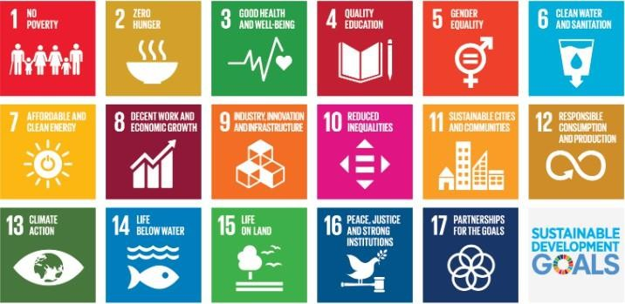
The internship aligns with SDG 9: Industry, Innovation, and Infrastructure by promoting the use of advanced technologies, including AI-assisted development, to build modern digital solutions. It also supports SDG 8: Decent Work and Economic Growth by enhancing technical skills and employability in the IT sector. The integration of efficient data systems and intelligent tools contributes to the development of scalable and sustainable digital infrastructure.
Figure 1.1: SDGs
1.7 Overview of Internship Report
This report provides a comprehensive overview of the work carried out during the internship. It begins with an introduction to the background, objectives, and methodologies adopted, followed by a detailed description of each project undertaken. The report highlights the technologies used, implementation processes, and key learnings, including the role of AI tools in development. It also discusses challenges faced and solutions implemented. Finally, the report concludes with the outcomes of the internship and the skills acquired throughout the experience.

Chapter 2
LITERATURE SURVEY
The rapid growth of web technologies and data-driven applications has significantly transformed modern software development practices. Various frameworks, programming languages, and tools have been developed to improve efficiency, scalability, and user experience in application development. In recent years, the integration of Artificial Intelligence (AI) tools into the development workflow has further accelerated the software development lifecycle, enabling developers to generate, optimize, and debug code more efficiently.
Python is one of the most widely used programming languages due to its simplicity and versatility. It is extensively applied in backend development, data processing, and automation tasks. Frameworks such as Flask provide lightweight solutions for building RESTful APIs, allowing seamless communication between frontend and backend systems. Flask is particularly suitable for developing scalable web applications and integrating with multiple databases.
Data management plays a crucial role in modern applications. Relational databases like SQL Server are commonly used for structured data storage, while NoSQL databases such as MongoDB and search engines like Elasticsearch are designed to handle unstructured and large-scale data efficiently. Techniques such as ETL (Extract, Transform, Load) are widely used for processing data from formats like Parquet and transforming it into usable forms for analysis and storage.
Web scraping has become an important method for automated data collection from websites. Using Python-based tools, developers can extract relevant information, process it, and present it through web applications. This reduces manual effort and supports data-driven decision-making.
Frontend development has evolved with the introduction of modern JavaScript libraries such as React, which enable the creation of dynamic and component-based user interfaces. The use of TypeScript enhances code reliability through static typing, while Tailwind CSS provides a utility-first approach for efficient and consistent styling. Design tools like Figma are widely used to create UI/UX prototypes, which can then be translated into functional applications.

In addition to traditional development tools, AI-assisted platforms such as Antigravity, Claude, and other prompt-based coding tools are increasingly being used in software development. These tools help in generating code snippets, suggesting optimizations, debugging errors, and accelerating development through natural language prompts. The integration of AI tools into development workflows enhances productivity and supports developers in implementing complex features more efficiently.
Modern applications also incorporate secure authentication mechanisms such as OTP-based login systems and integrate payment gateways like Razorpay for seamless transactions. These features improve user experience and ensure secure and reliable system interactions.

Overall, the technologies and approaches used during the internship reflect current industry standards and highlight the growing importance of AI-assisted development alongside traditional programming practices. They demonstrate how multiple tools and frameworks can be effectively combined to build scalable, efficient, and user-centric applications.

Chapter 3
METHODOLOGY
The methodology followed during the internship was designed to ensure a systematic approach to learning and implementation, combining traditional software development practices with AI-assisted tools. The process was carried out in multiple phases, progressing from foundational learning to the development of complete full-stack applications.
The initial phase focused on building a strong foundation in Python programming. Core concepts such as variables, data structures, control flow, and functions were learned and practiced through small exercises. This phase established the base required for backend development and data processing tasks.
The next phase involved working on a data quality testing platform, where the methodology included understanding system workflows, analyzing how data validation processes function, and testing the application using databases such as MySQL, MongoDB, and Elasticsearch. This helped in gaining insights into handling structured and unstructured data in real-world systems.
Following this, a data pipeline application was developed to process Parquet files and load them into SQL Server. The methodology followed the ETL (Extract, Transform, Load) process, where data was extracted from files, transformed into a suitable format, and loaded into the database. Flask was used to develop RESTful APIs for backend operations, while a user interface was built using HTML and Jinja templates. API endpoints were tested using Postman to ensure accuracy and reliability.
In parallel, a web scraping application was implemented. The methodology involved analyzing website structures, extracting relevant data using Python-based scraping techniques, and displaying the results through a Flask-based interface. This ensured effective integration between backend processing and frontend presentation.
The final phase focused on frontend development using React. A pre-designed Figma layout was converted into a fully functional and responsive web application. The process involved breaking down the design into reusable components, implementing them using React with TypeScript, and styling them using Tailwind CSS. During this phase, AI-assisted development tools such as Antigravity, Claude, and similar platforms were actively used to generate code snippets, refine UI components, debug issues, and improve development speed through prompt-based interactions. Features such as OTP-based authentication, backend API integration readiness, and payment functionality using Razorpay were incorporated into the application.
Throughout the internship, continuous testing, debugging, and validation were performed to ensure proper functionality and performance. The methodology emphasized modular development, integration of multiple technologies, iterative improvement, and the effective use of AI tools to enhance productivity and streamline the development process.

Chapter 4
PROJECT MANAGEMENT
4.1 Internship Timeline
The internship was carried out in a phased and structured manner from January 5 to April 25, ensuring a smooth progression from foundational learning to advanced application development. The initial phase focused on learning Python fundamentals, which formed the base for all subsequent tasks. This was followed by working on a data quality testing platform, where database interactions and validation workflows were explored.The development phase included building a data pipeline application and a web scraping system, where backend logic, data processing, and frontend integration were implemented. In the final phase, emphasis was placed on frontend development by converting a Figma-based design into a production-ready React application. During this phase, AI-assisted tools such as Antigravity and Claude were used to support code generation, UI development, and debugging through prompt-based interactions, improving development efficiency.
The internship concluded with testing, integration, and refinement of all developed applications to ensure functionality and completeness.
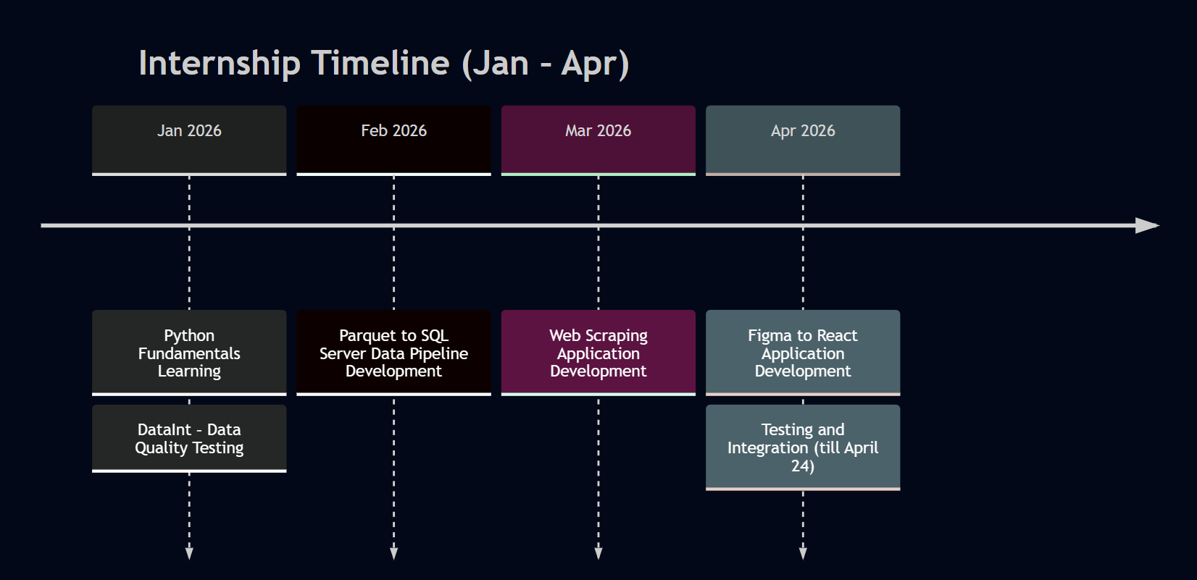
Figure 4.1: Internship Timeline
4.2 Risk Analysis
Several potential risks were identified during the internship, particularly due to the use of multiple technologies and tools. One major risk was the learning curve associated with new frameworks such as Flask, React, and database systems. This was mitigated through continuous practice, documentation review, and guided learning.
Another risk involved integration challenges between frontend and backend components, which could affect application functionality. This was addressed by testing APIs using Postman and validating data flow across systems. The use of AI-assisted tools also introduced potential risks such as dependency on generated code and inaccuracies in suggestions. To mitigate this, all AI-generated outputs were carefully reviewed, tested, and modified before implementation.
Data processing errors in the ETL pipeline and web scraping tasks were also considered risks and were handled through validation and testing at each stage. Additionally, time management was a key concern due to multiple project deliverables, which was managed by dividing tasks into smaller milestones and maintaining a consistent workflow.
4.3 Internship Budget
The internship was primarily focused on learning and development and did not require significant financial investment. Most of the technologies used, including Python, Flask, React, TypeScript, and Tailwind CSS, are open-source and freely available. Development and testing were carried out on local systems, minimizing infrastructure costs.
Tools such as Postman were used for API testing, and AI-assisted platforms like Antigravity and Claude were utilized to support development tasks. These tools either provided free access or required minimal cost, making the overall development process cost-effective. By leveraging open-source technologies and AI-assisted tools, the internship maintained a highly efficient and economical approach while achieving all project objectives.

Chapter 5
ANALYSIS AND DESIGN
5.1 Requirements
- Data processing and storage using SQL Server, MongoDB, and Elasticsearch
- File upload and ETL operations for Parquet data pipeline
- Web scraping functionality to extract and display data
- Responsive frontend application using React based on Figma design
- User authentication (OTP) and payment integration (Razorpay)

5.2 Choosing Devices
- Development carried out on a standard laptop/PC with adequate RAM and processing power
- No specialized hardware required as projects are software-based
- Internet connectivity required for API calls, documentation, and AI tools
- Browser (Chrome) used for frontend testing and debugging
- Local environment used for development and execution

5.3 Database and Data Management
- SQL Server used for structured data storage in pipeline project
- MongoDB used for handling NoSQL data
- Elasticsearch used for efficient data searching and analysis
- Data transformation performed using ETL process
- JSON format used for data exchange between frontend and backend

5.4 Security and Privacy
- Input validation implemented in backend APIs
- Secure handling of user data in authentication system
- API endpoints tested to avoid unauthorized access
- No sensitive real-world data used during development
- AI-generated code reviewed to prevent vulnerabilities

5.5 System Flow Chart
- User interacts with frontend interface (UI)
- Request is sent to backend through API calls
- Backend processes request (data validation, transformation, scraping)
- Data is stored/retrieved from database
- Response is sent back and displayed on the frontend
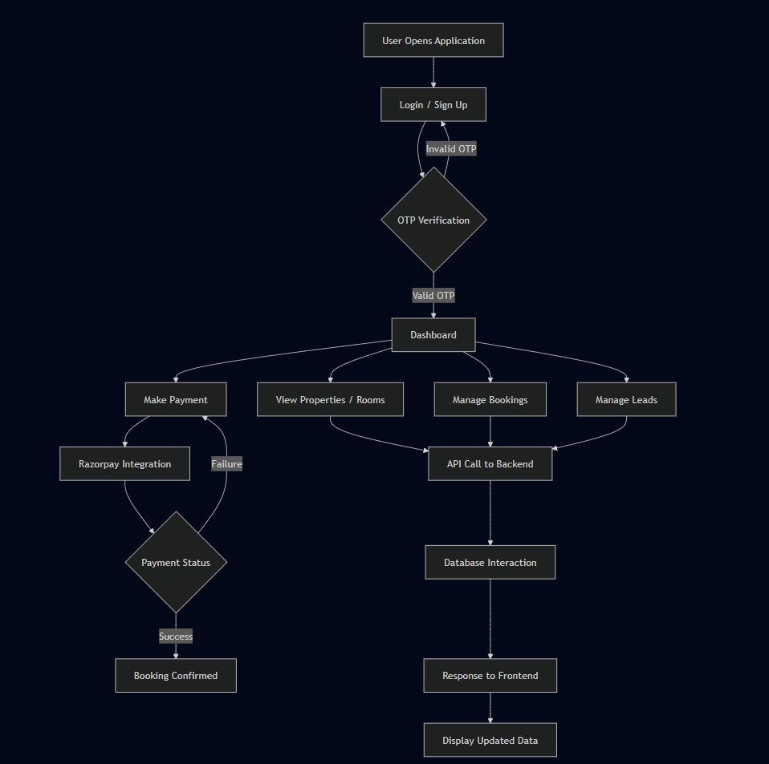
Figure 5.1: Workflow for StaynGo Hotel Booking

5.6 Design Considerations
- Modular design with separation of frontend, backend, and database layers
- Responsive UI design for multiple screen sizes
- Reusable components in React for better maintainability
- Efficient data handling for large datasets

5.7 Prototype Validation
- Backend APIs tested using Postman
- Frontend validated through browser testing
- Data pipeline verified with sample Parquet files
- Web scraping results checked against actual website data
- React application tested for responsiveness and functionality

5.8 Future Design Enhancements
- Integration of real-time data processing capabilities
- Improved UI/UX design with advanced features
- Enhanced security mechanisms for authentication and data handling
- Deployment of applications on cloud platforms
- Increased use of AI tools for automation and optimization

Chapter 6
HARDWARE, SOFTWARE AND SIMULATION
6.1 Hardware
The internship primarily focused on software development; therefore, no specialized hardware components were required. All development activities were carried out using a standard personal computer or laptop with sufficient processing power and memory to support development tools and applications. The system was used for coding, running backend servers, testing APIs, and executing frontend applications.
A stable internet connection was also essential for accessing documentation, using online tools, integrating APIs, and utilizing AI-assisted development platforms. Overall, the hardware requirements were minimal and aligned with typical software development environments.

6.2 Software Development Tools
Various software tools and technologies were used throughout the internship to support development, testing, and deployment of applications:
- Programming Language: Python was used for backend development and data processing tasks.
- Framework: Flask was used to build RESTful APIs and handle server-side logic.
- Frontend Technologies: React, TypeScript, and Tailwind CSS were used to develop responsive and modern user interfaces.
- Templating Engine: Jinja templates were used for dynamic content rendering in Flask-based applications.
- Databases: SQL Server for structured data, MongoDB for NoSQL data, and Elasticsearch for search and analytics.
- API Testing Tool: Postman was used to test and validate API endpoints.
- Code Editor: Visual Studio Code was used for writing and managing code.
- Version Control : Git was used for code management and tracking changes.
- AI-Assisted Tools: Platforms such as Antigravity, Claude, and similar tools were used to assist in code generation, debugging, and improving development efficiency through prompt-based interactions.

Table 6.1: Software Development Tools
Tool | Purpose
Python | Backend & data processing
Flask | API development
React | Frontend UI
Postman | API testing
Antigravity / Claude | AI-assisted coding

6.3 Software Code
The software code developed during the internship consisted of multiple components, including backend scripts, API endpoints, and frontend modules. The backend code was written in Python using Flask to handle data processing, file handling, and database operations. RESTful APIs were implemented to facilitate communication between frontend and backend systems.
Frontend code was developed using React with TypeScript, following a component-based architecture. Tailwind CSS was used for styling and ensuring responsiveness across different devices. The codebase was structured into reusable components to improve maintainability and scalability.

6.3.1 Code Snippets
1.
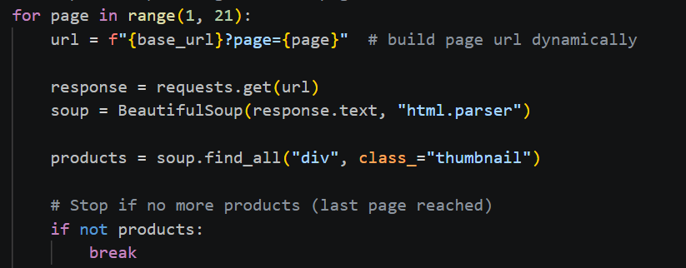
Figure 6.1: Using BeautifulSoup for Web Scraping

2.
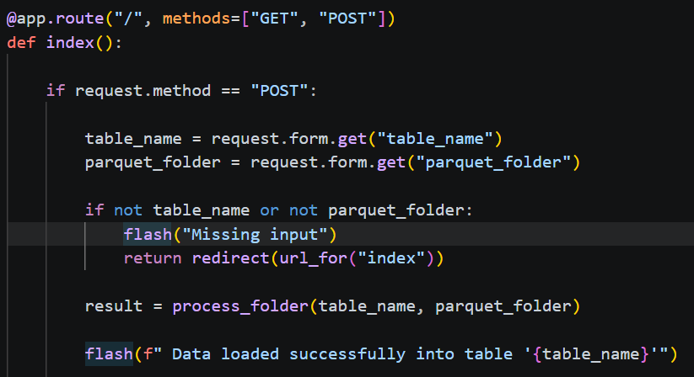
Figure 6.2 : Creating API Endpoint
6.4 Simulation
Since the internship focused on software applications, simulation was carried out through testing in a controlled environment. Backend APIs were tested using Postman to verify request-response cycles, while frontend applications were tested in web browsers for proper rendering and responsiveness.
Various scenarios such as file uploads, data processing, API responses, and authentication were tested. Integration testing ensured smooth communication between frontend, backend, and databases. Additionally, AI-assisted tools were used to explore alternative solutions and improve development efficiency.

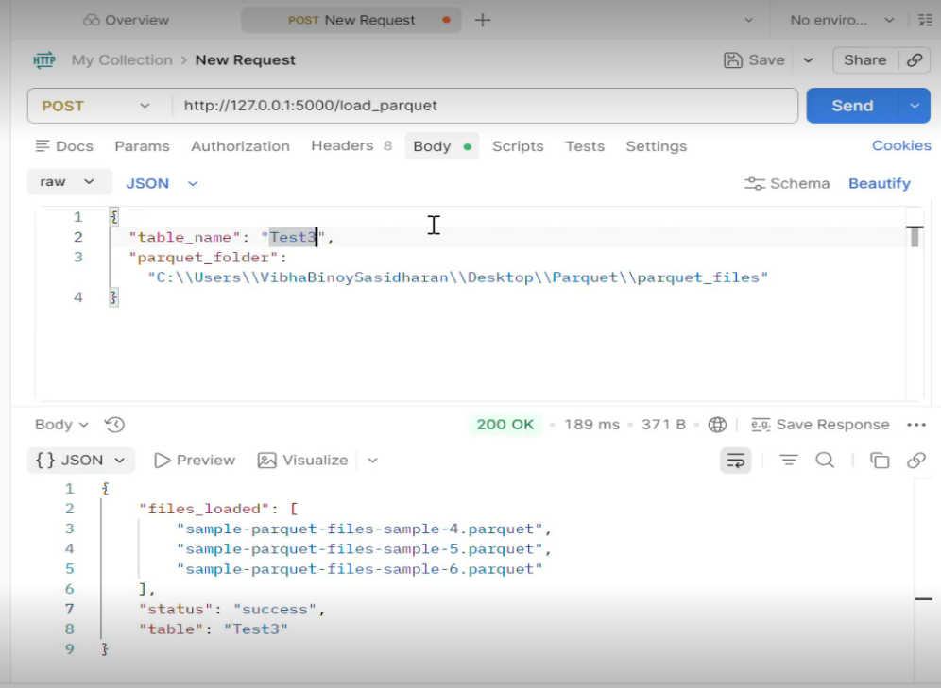
Figure 6.3: API testing using Postman
Chapter 7
EVALUATION AND RESULTS
7.1 Test Points
- Verification of API endpoints using Postman (Flask backend)
- Testing of file upload and data insertion in SQL Server (Parquet pipeline)
- Validation of web scraping output for different websites
- UI testing of React application for responsiveness and functionality
- Testing of authentication (OTP) and payment integration features

7.2 Test Plan
- Backend APIs were tested using Postman for request-response validation
- Frontend applications were tested in web browsers (Chrome)
- Functional testing was performed for each feature (upload, scraping, login, payment)
- Integration testing ensured smooth communication between frontend and backend
- AI-generated code was reviewed, executed, and debugged before final implementation

7.3 Test Result
- All API endpoints returned correct responses with expected data
- Parquet files were successfully processed and inserted into SQL Server
- Web scraping application accurately extracted and displayed required data
- React application worked smoothly across different screen sizes
- Authentication and payment features functioned correctly after debugging

7.3.1 Outputs
1. Parquet Loader
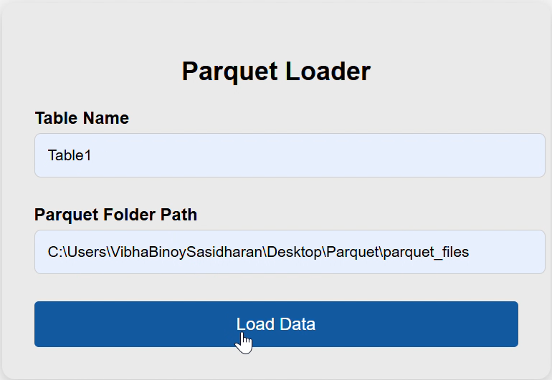
Figure 7.1: Parquet Loader UI

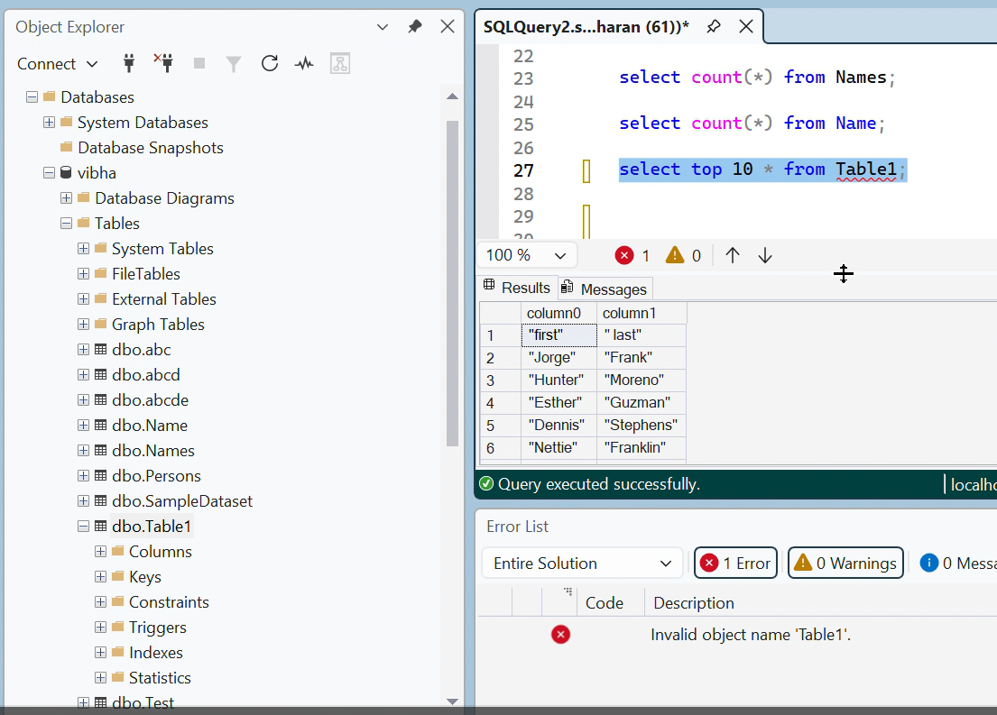
Figure 7.2: Data Pipeline Output

2. Project: DataInt- Intelligent Data Quality Testing Platform
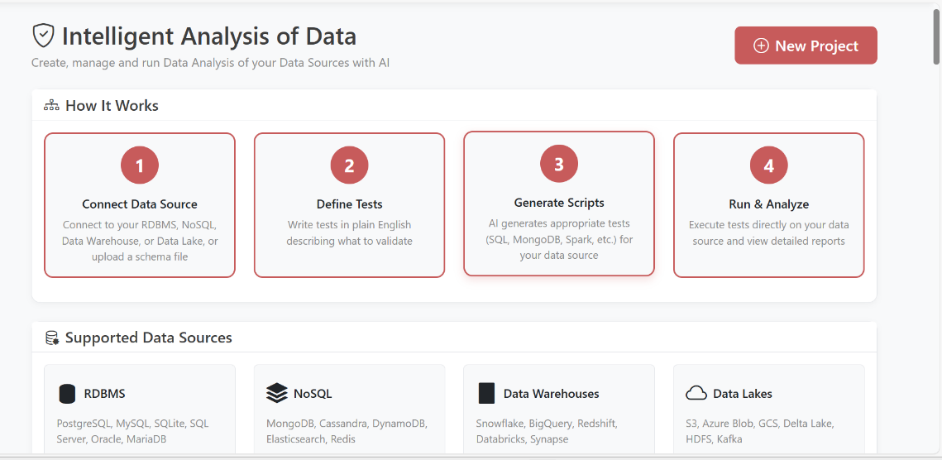
Figure 7.3: UI of Testing Platform(1)

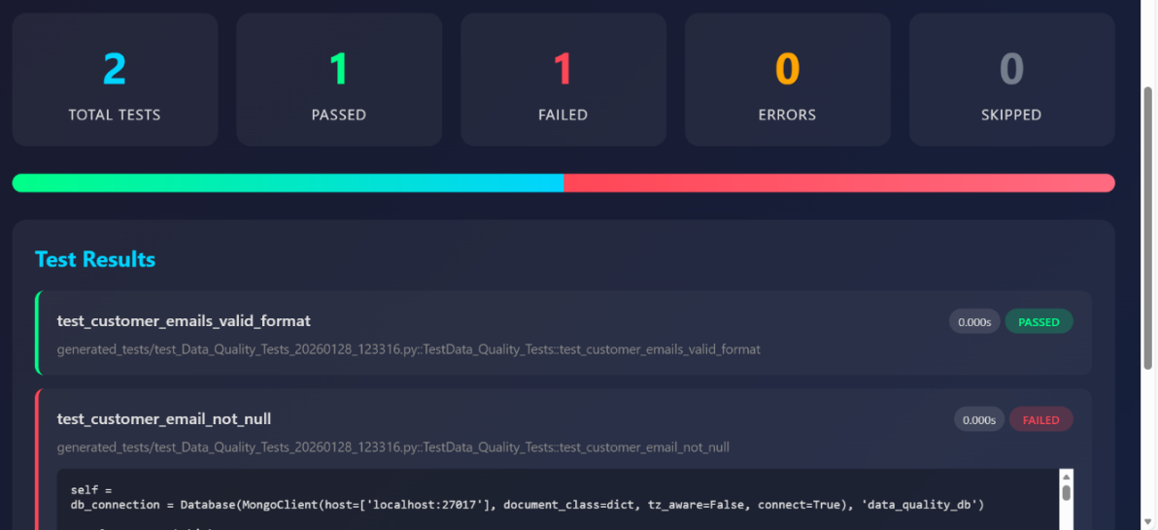
Figure 7.4: Test Results
3. Web Scraper
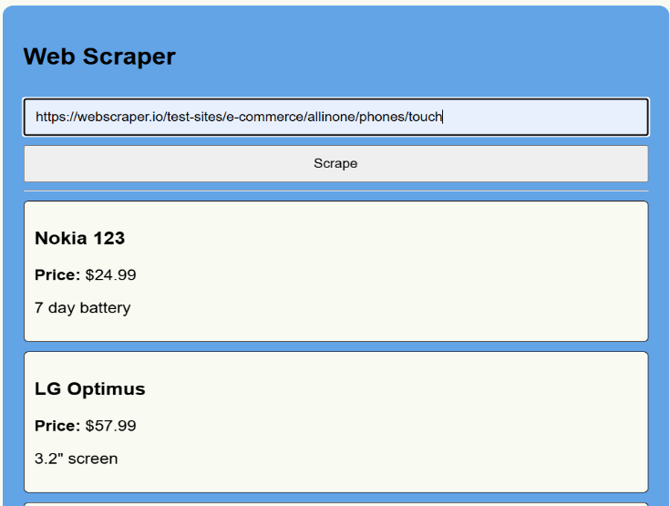
Figure 7.5: Web Scraper UI

4. Project: StaynGo- Hotel Booking Platform
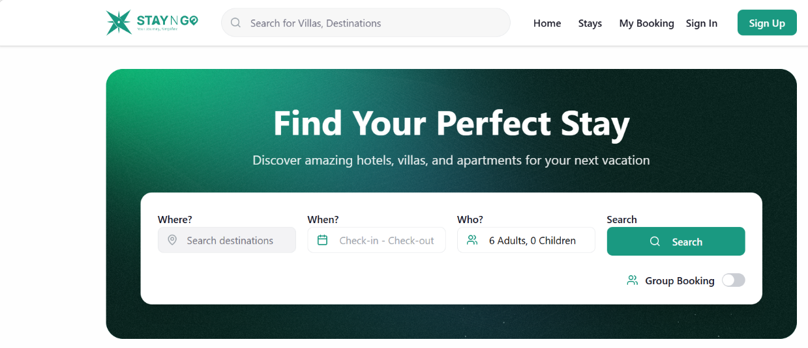
Figure 7.6: StaynGo Web Design for User(1)
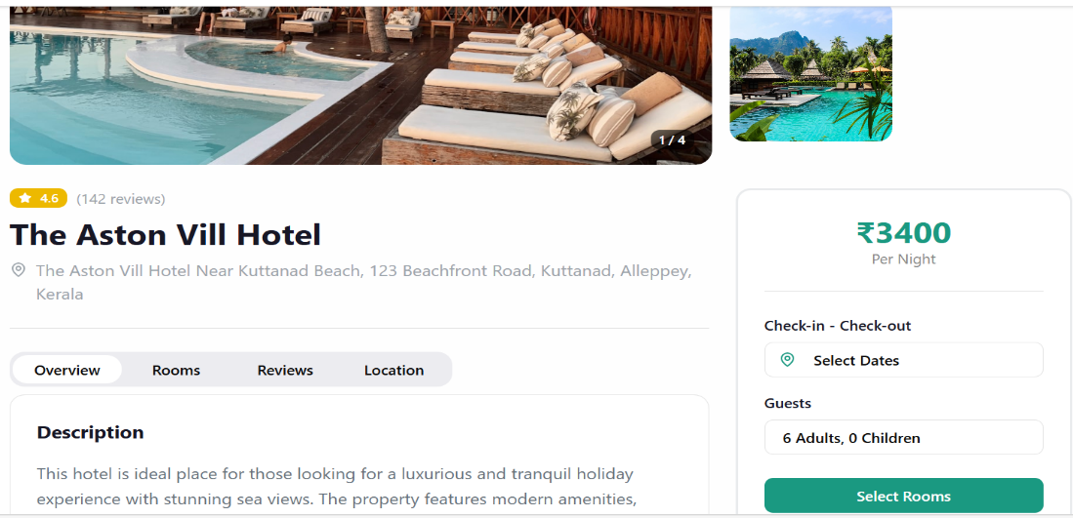
Figure 7.7: StaynGo Web Design for User(2)
7.4 Insights
- Integration testing highlighted the importance of smooth communication between frontend, backend, and database systems
- Handling real-world data improved understanding of data processing challenges and error handling
- AI-assisted tools such as Antigravity and Claude significantly accelerated development and debugging
- Learned the importance of validating and refining AI-generated code before implementation
- Enhanced practical skills in API testing, UI responsiveness, and performance optimization

Chapter 8

SOCIAL, LEGAL, ETHICAL, SUSTAINABILITY AND SAFETY ASPECTS

8.1 Social Aspects
The applications developed during the internship contribute to improving efficiency and accessibility in digital systems. Solutions such as data pipelines, web applications, and property management systems enhance productivity by automating manual processes and enabling better data handling. The use of modern web technologies ensures that applications are accessible across multiple devices, improving user experience and inclusivity.
Additionally, the integration of AI-assisted tools in development reflects the evolving nature of the software industry, where technology is used to enhance human productivity rather than replace it. This promotes skill development and adaptability among developers, which is essential in today’s digital society.

8.2 Legal Aspects
Legal considerations were taken into account while developing applications, particularly in terms of data handling and usage. Care was taken to ensure that data used in testing and development did not violate privacy or confidentiality norms. Web scraping activities were performed responsibly, ensuring that publicly available data was used without breaching website policies or terms of service.
Furthermore, the use of third-party tools, libraries, and frameworks adhered to their respective licenses and usage guidelines. Proper attention was given to secure handling of user data, especially in features such as authentication and API interactions, to ensure compliance with general data protection practices.

8.3 Ethical Aspects
Ethical practices were maintained throughout the internship by ensuring responsible use of technology and data. AI-assisted tools such as Antigravity and Claude were used as support systems to enhance development efficiency, while maintaining originality and understanding of the implemented code. All generated outputs were reviewed and modified as required, ensuring that the developer retained control over the final implementation.
Additionally, ethical considerations were followed in data usage, avoiding misuse or manipulation of data. Transparency, accuracy, and accountability were maintained in all development activities.

8.4 Sustainability Aspects
The internship adopted a sustainable approach by utilizing digital tools and open-source technologies, reducing the need for physical resources. Efficient coding practices and optimized data handling were followed to minimize computational overhead and improve system performance.
The use of cloud-ready and scalable technologies ensures that the developed applications can handle increasing data and user demands without excessive resource consumption. Moreover, AI-assisted development tools helped reduce development time and effort, contributing to efficient use of resources.

8.5 Safety Aspects
Safety in software development was addressed by ensuring secure application design and data handling practices. Measures such as input validation, proper API handling, and secure authentication mechanisms were considered to reduce vulnerabilities. Testing and debugging were performed regularly to identify and fix errors that could affect system reliability.
In addition, precautions were taken while integrating external tools and APIs to ensure that sensitive data was not exposed. The use of controlled testing environments further ensured that the applications functioned safely before deployment.

Chapter 9
CONCLUSION
The internship provided valuable practical exposure to modern software development practices and enabled the application of theoretical knowledge in real-world scenarios. Throughout the internship, multiple projects were undertaken that covered a wide range of concepts, including Python programming, backend development using Flask, database management, data processing pipelines, web scraping, and frontend development using React. This comprehensive experience helped in developing a deeper understanding of full-stack application development.
One of the key outcomes of the internship was the successful implementation of multiple functional systems, including a data quality testing platform, a Parquet to SQL Server data pipeline, a web scraping application, and a modern property management web application. These projects involved working with both structured and unstructured data, designing APIs, and building user-friendly interfaces. The experience of integrating frontend and backend components provided a clear understanding of how complete systems operate in a real-world environment.
An important aspect of this internship was the use of AI-assisted development tools such as Antigravity and Claude. These tools were effectively utilized to generate code, debug issues, and accelerate development through prompt-based interactions. This not only improved productivity but also provided insight into how AI is transforming the software development process. At the same time, careful validation and testing ensured that the quality and reliability of the code were maintained.
The internship also enhanced problem-solving skills, logical thinking, and the ability to learn and adapt to new technologies. Working on multiple projects within a limited timeframe improved time management and the ability to handle complex tasks efficiently. Continuous testing and debugging further strengthened the understanding of software reliability and performance.
In conclusion, the internship was a highly enriching experience that contributed significantly to both technical and professional development. It provided hands-on experience with industry-relevant tools and technologies, along with exposure to emerging trends such as AI-assisted development. The knowledge and skills gained during this period will serve as a strong foundation for future academic projects and professional career growth in the field of software development.
REFERENCES
- Stack Overflow
https://stackoverflow.com
Used for resolving coding errors and understanding practical implementation issues.
- GeeksforGeeks
https://www.geeksforgeeks.org
Referred for learning programming concepts and implementation techniques.
- TutorialsPoint
https://www.tutorialspoint.com
Used for understanding fundamental and advanced topics in software development.
- YouTube
https://www.youtube.com
Used for visual tutorials and step-by-step explanations of technologies.
- Antigravity
(AI-assisted development tool)
Used for generating and refining code through prompt-based interactions.
- ChatGPT
https://chat.openai.com
Used for guidance, debugging support, and improving development efficiency.

APPENDIX – A

Figure A 1: Data Uploaded in SQL Server for Parquet Loader

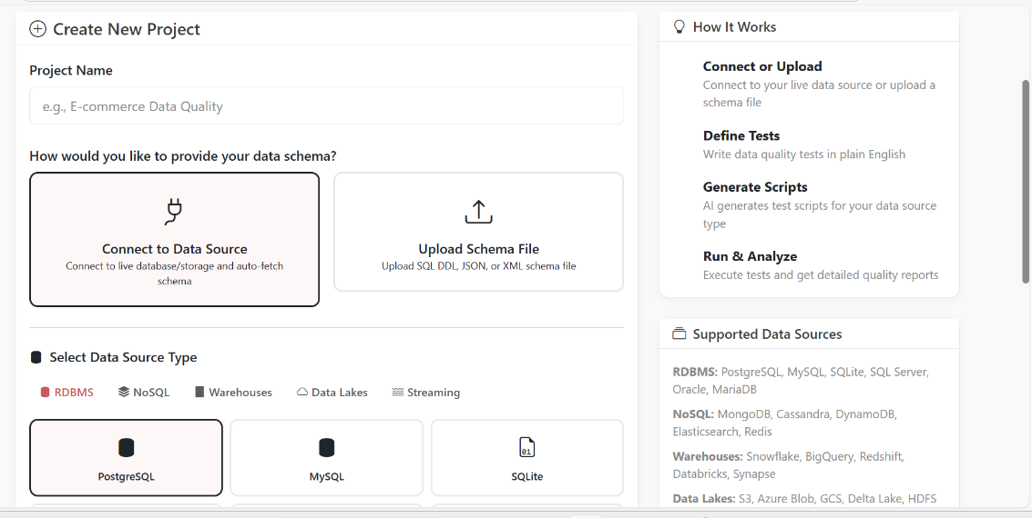
Figure A 2: UI for DataInt Testing Platform

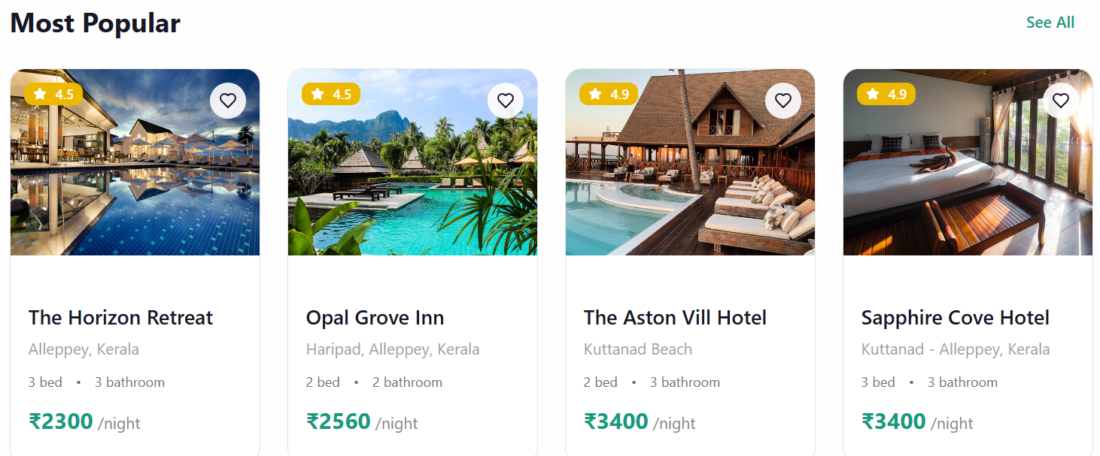
Figure A 3: UI for StaynGo Hotel Booking Platform

